**Multiple Choice Questions**

13) A basic model for the movement of the price of a stock supposes that on each day the stock’s price either moves up 1 unit with probability p or moves down 1 unit with probability 1 − p. The changes on different days are assumed to be independent. What is the probability that after 2 days the stock will be at its original price? [answer should be in terms of p]

**For the stock to return to its original price, we either have UD or DU, each of which occurs with probability p(1 - p). Thus the probability that the stock is at its original price after two days is 2p(1 - p).**

**Worth 1 point;**

**1 point if correct answer 2p(1-p)**

**.5 point if some (good) work shown but incorrect answer**

**0 points if no answer or incorrect answer and no work shown.**

14) A basic model for the movement of the price of a stock supposes that on each day the stock’s price either moves up 1 unit with probability p or moves down 1 unit with probability 1 − p. The changes on different days are assumed to be independent. What is the probability that after 3 days the stock’s price will have increased by 1 unit? [answer should be in terms of p]

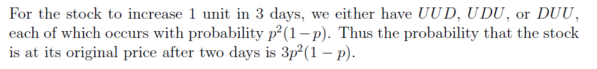

**Worth 1 point;**

**1 point if correct answer 3p2(1-p)**

**.5 point if some (good) work shown but incorrect answer**

**0 points if no answer or incorrect answer and no work shown.**

22) A stock market analyst wants to estimate the average return on certain stock. A random sample of 15 days yields an average (annualized) return of 10.37% and a standard deviation of 3.5%. Assuming a normal population of returns, give a 95% confidence interval for the average return on this stock.

**Answer should be xbar +/ - 1.96 s/sqrt(n). People might have used the correct t value instead of 1.96 which is also fine. I think some students made this problem more complicated than intended so as long as they give some sort of confidence interval give credit. The problem is worth 1 point.**

**> zsum.test(mean.x=10.37,sigma.x=3.5,n.x=15)**

**One-sample z-Test**

**data: Summarized x**

**z = 11.475, p-value < 2.2e-16**

**alternative hypothesis: true mean is not equal to 0**

**95 percent confidence interval:**

**8.598788 12.141212**

**> tsum.test(mean.x=10.37,s.x=3.5,n.x=15)**

**One-sample t-Test**

**data: Summarized x**

**t = 11.475, df = 14, p-value = 1.657e-08**

**alternative hypothesis: true mean is not equal to 0**

**95 percent confidence interval:**

**8.431765 12.308235**

**Worth 1 point;**

**1 point if correct answer**

**.5 point if some (good) work shown but incorrect answer**

**0 points if no answer or incorrect answer and no work shown.**

**Short Answer**

1. A salesperson in a large bicycle shop is paid a bonus if he sells more than 4 bicycles a day. The probability of selling more than 4 bicycles a day is only .40. If the number of bicycles sold is greater than 4, the distribution of sales is as shown in the table below. The shop has four different models of bicycles. The amount of the bonus paid out varies by type. The bonus for model A is $10; 40% of the bicycles sold are of this type. Model B accounts for 35% of the sales and pays a bonus of $15. Model C has a bonus rating of $20 and makes up 20% of the sales. Finally, model D pays a bonus of $25 for each sale but accounts for only 5% of the sales. Develop a simulation model to calculate the bonus a salesperson can expect in a day. Also report a 95% confidence interval for the mean bonus amount.

**Grading: Give two points for correctly getting the expected bonus in a day and one point for the CI (3 pts total).**

**> library(boot)**

**> set.seed(1)**

**> n=10000**

**> bonusvals=rep(0,n)**

**> for(i in 1:n) {**

**+ sellmore=runif(1)**

**+ if (sellmore<.4) {**

**+ howmany = sample(size=1,c(1,2,3,4),**

**+ prob=c(.35,.45,.15,.05),**

**+ replace=TRUE)**

**+ bonusvals[i] = sum(sample(size=howmany,**

**+ c(10,15,20,25),**

**+ prob=c(.4,.35,.20,.05),**

**+ replace=TRUE))**

**+ }**

**+ }**

**> bootmean <- function(x, d) mean(x[d])**

**> boot.out <- boot(bonusvals, bootmean, 10000)**

**> mean(bonusvals)**

**[1] 11.242**

**> boot.ci(boot.out, type = 'basic')**

**BOOTSTRAP CONFIDENCE INTERVAL CALCULATIONS**

**Based on 10000 bootstrap replicates**

**CALL :**

**boot.ci(boot.out = boot.out, type = "basic")**

**Intervals :**

**Level Basic**

**95% (10.92, 11.56 )**

**Calculations and Intervals on Original Scale**

1. A fund manager is considered three different investments. The first is a stock fund, the second is a bond fund, and the third is a money-market fund that yields a rate of .05. The yearly statistics of all the funds are as follows:



The correlation between the stock and bond fund is 0.10

**Grading-parts a-c 1 point each-give half point credit as appropriate. Part d is worth 2 points-partial credit as appropriate (1 or 1.5 points).**

**Looking at a few papers some students used 0 for the risk free rate instead of the given 0.5. Give half off for that fort parts c and d if they did that.**

1. Find the risk and return of the minimum variance portfolio consisting of the stock and bond funds.

**Call:**

**globalMin.portfolio(er = er, cov.mat = covmat)**

**Portfolio expected return: 0.1752833**

**Portfolio standard deviation: 0.1833003**

**Portfolio weights:**

**Stock Bond**

**0.2809 0.7191**

1. Create a plot of the efficient frontier, allowing short sales.

**> ef=efficient.frontier(er,covmat)**

**> plot(ef$sd,ef$er,type="l",xlab="risk",ylab="return")**

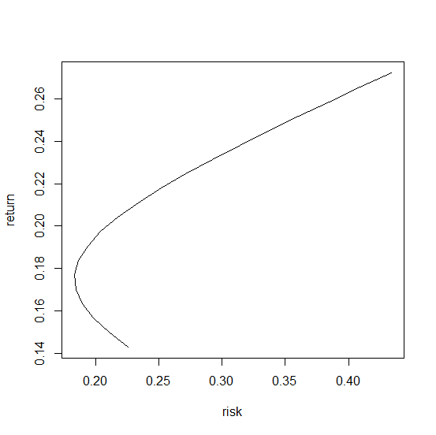

1. Find the tangent portfolio consisting of the stock and bond funds; produce the weights for the tangent portfolio, as well as the risk and return of the tangent portfolio.

**> tf=tangency.portfolio(er,covmat,risk.free=0.05)**

**> tf**

**Call:**

**tangency.portfolio(er = er, cov.mat = covmat, risk.free = 0.05)**

**Portfolio expected return: 0.191609**

**Portfolio standard deviation: 0.1948776**

**Portfolio weights:**

**Stock Bond**

**0.4623 0.5377**

1. Suppose you with to construct a portfolio with an expected return of .28 but all you can do is go long or short the two risky funds. What are the appropriate portfolio weights and the resulting portfolio standard deviation? What reduction in standard deviation could you attain if instead you used the money market fund and the tangent portfolio to construct a portfolio that returned .28?

**With the two assets weights would be 1.44 and -0.44 and risk = 46.2%**

**> efficient.portfolio(er,covmat,target.return=0.28)**

**Call:**

**efficient.portfolio(er = er, cov.mat = covmat, target.return = 0.28)**

**Portfolio expected return: 0.28**

**Portfolio standard deviation: 0.462312**

**Portfolio weights:**

**Stock Bond**

**1.4444 -0.4444**

**With the tangent portfolio we need to solve **

**So now we have 1.62 in the tangent portfolio and -0.62 in case. This portfolio has risk/return of 0.28 and 0.31 respectively. So we obtain the same return but risk went from 46.2% to 31.5%.**



1. In this exercise, you will show that β for a portfolio is a linear combination of the β ’s for the stocks in the portfolio.

Consider the Market Model equation for two stocks A and B:



For each regression, it is assumed and are independent of  . Create a portfolio of stocks A and B with share of wealth  invested in stock A and share  invested in B such that  Show that the beta of the portfolio, denoted βp , satisfies .

Hint: one way of writing  is .

**Solution-worth three points. Only give .5 points if numerical example given. Want some sort of real result as follows. Not much partial credit to give here.**

**Need to know Cov(X+Y,Z) =Cov(X,Z)+Cov(Y,Z)**

**The weighted portfolio is **

**Then**

